Tips for searching for images in box

- Set the view to Grid view.
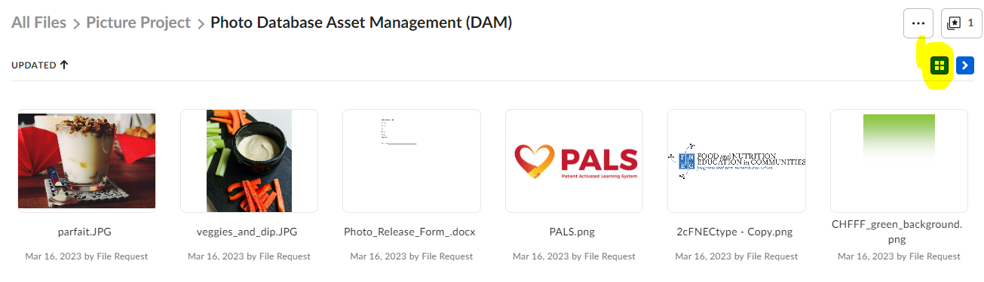

- Click in the Search Files and Folders field the check Only Search inside of ‘Photo Database Asset Management.
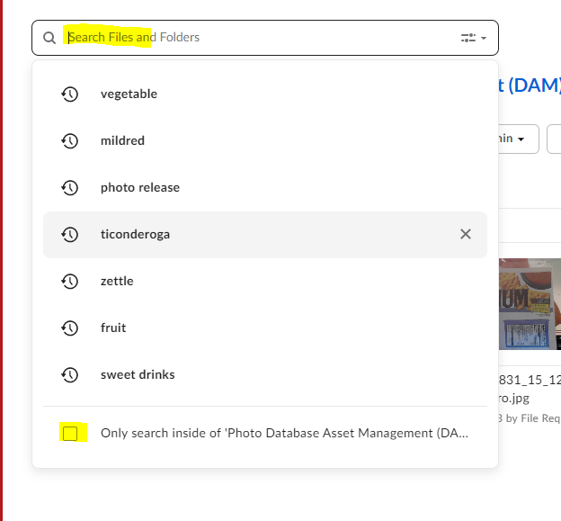
- To see to all images, clear the search term from the search field or click on Photo Database Asset Management (DAM) at the top of the screen.

